Pocket Chef SD3A
This is a team of three including:
Dylan : Focusing on Database & Backend Development.
Josh : Testing & Designing the apps Frontend & UX Design.
Luke : Sourcing & Wiring the IOT Hardware setup.

App Description
Pocket Chef is a cooking assistance app, displaying adjustable recipes designed around being easily followed and cooked by both beginner cooks and more knowledgeable chefs alike.
With the addition of a PI powered High Temperature Thermometer, the app monitors and tracks the state of different meats to set levels of cooking, notifying the user when it has reached its desired state.
The thermometer allows the app to know when a steak for example should stop cooking for rare, medium, or well done, working across steaks, chicken, fish, and other red and white meats.

Breakdown
Pocket Chef has been designed to:
-Allow users to be more confident with cooking
-Teach beginners that cooking isn't too tricky
-Save the worries of waiting around for food to cook leave and come back to it
There is a variety of information available to the user past just the temperature supplied by the thermometer such as estimated cook time, how many people it feeds, and the relative difficulty of a meal for beginners.
Pocket Chef’s included hardware, consisting of a Raspberry Pi Zero and attached AA Battery slot and High Temperature Thermometer, work to provide a highly portable, compact setup to assist beginners and cooking the perfect meal.

A Rough Pi Zero breadboard schematic has been provided below:
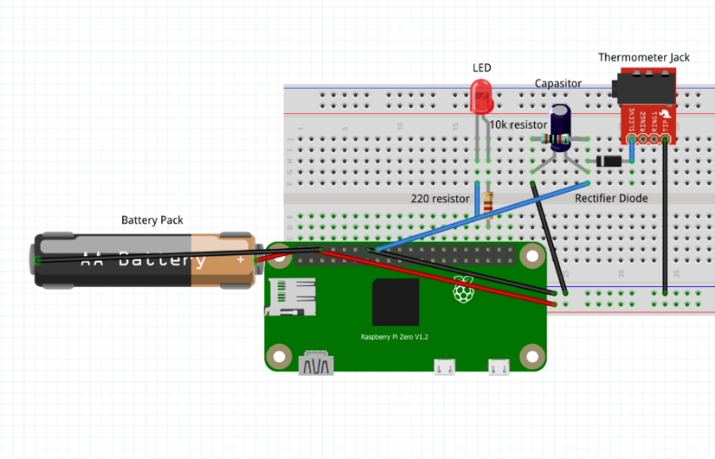
This shows the wiring of the battery pack, although in the prototype it is an attached HAT, connecting to a controlled LED as a visual indicator of both power and cooking state, and the female jack wired through a capacitor which allows for a plug in thermometer for easy replacement and a more compact design.

Ui Mock-up (by Josh)

